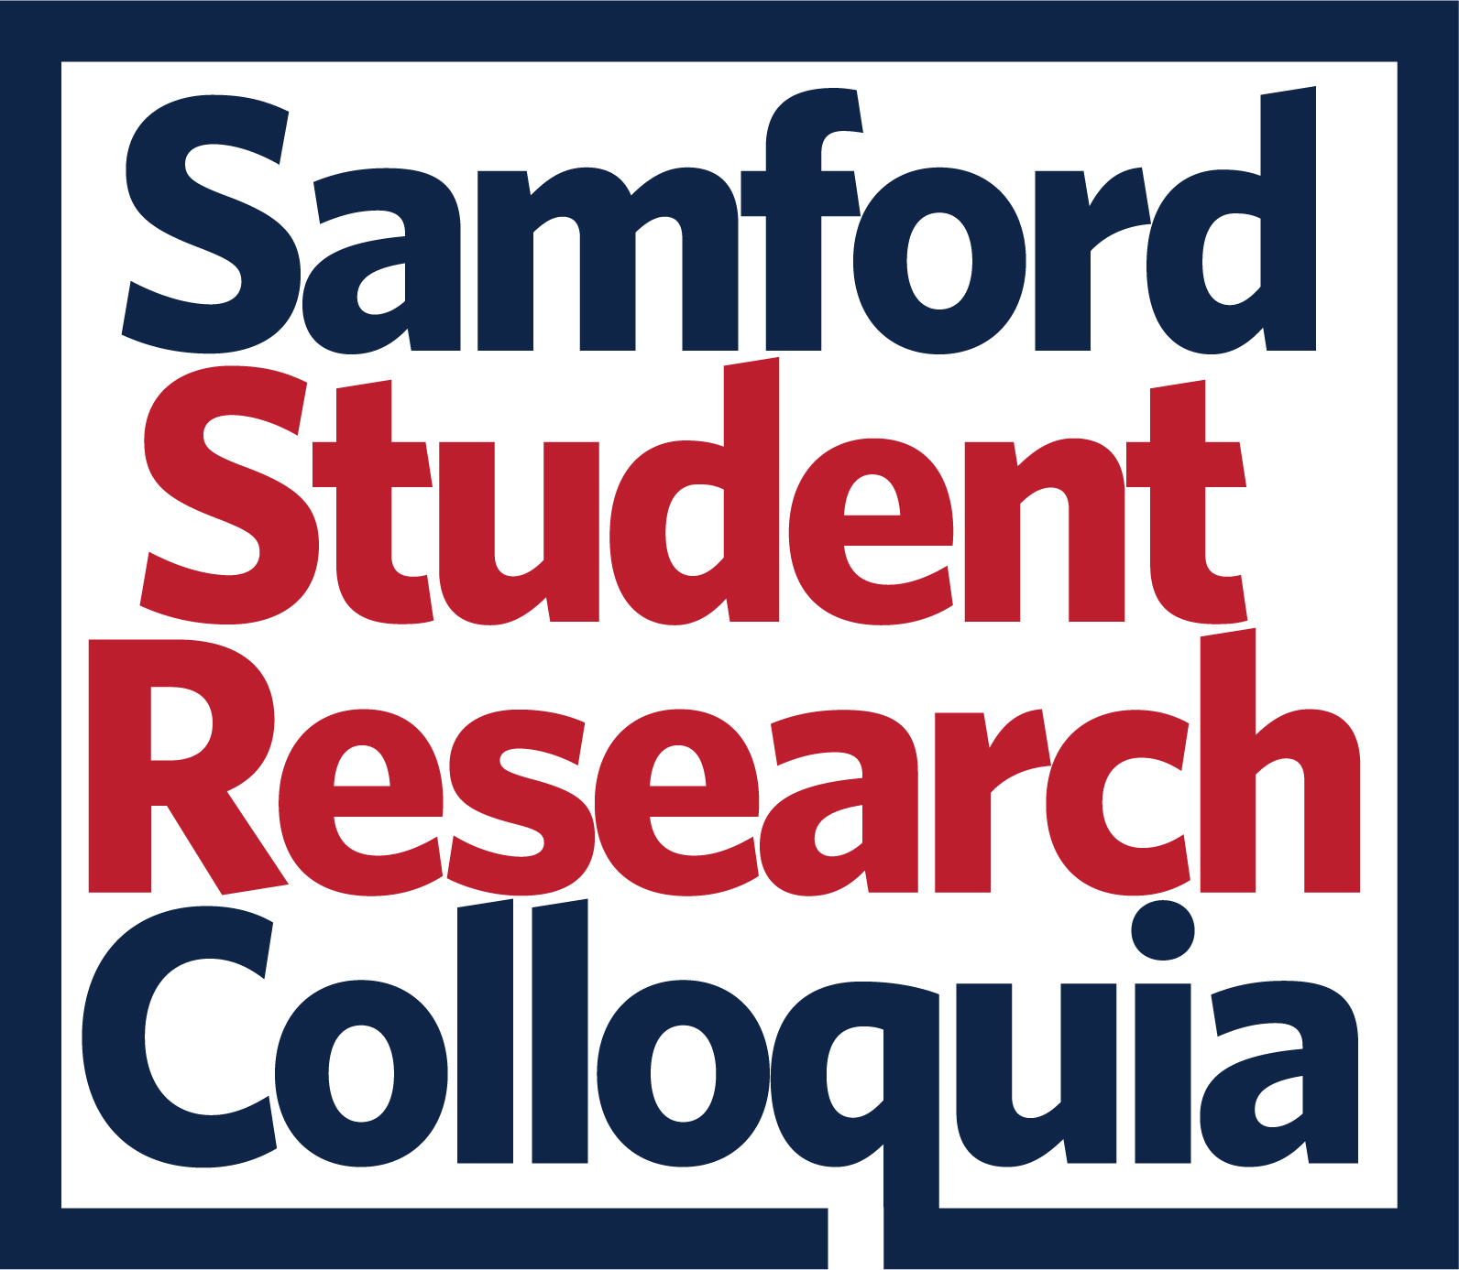
SSRC Abstract Expectations
It is expected that all presenters will work with their research mentor(s) or another Samford faculty member to ensure their abstract submission adheres to the following guidelines and policies:

Formatting
- Max length = 2000 characters
- Don’t include references in the abstract; these can be included on the poster.
- Try to use plain text only…no images, graphics, or special characters.

Audience
- Your abstract should be written for and understandable to a general audience.
- Avoid technical language if possible. If not, provide explanations of appropriate terminology.

Restrictions
- Unique Central Research Question: Each abstract submission must address a unique central research question. No two abstracts should be identical in the research question they explore.
- Presenter Restriction: Each student is permitted to be a presenter or co-presenter on at most one abstract submission.

Content
Try to address all of the following in your abstract, not necessarily in the order listed. Items (1), (2), and (3) must be addressed. Abstract reviewers understand that different disciplines have different norms.
- Central research question – What is the purpose of your project?
- Context – How does your work fit into a larger scholarly context within your field?
- Methods / processes – How did you attempt to address your research question?
- Findings / results
- Importance / implications – Why is your work important? What are its implications?
- Contribution – In what ways does your work make a unique contribution to your field?

Questions
If you have questions about this form, please email the Office of Research: research@samford.edu.

